The Journey of Our Food: From Farm to Bin

Introduction 2
Title 2
Authors 2
Summary of the scenario 2
Age of the students 2
‘Data Science Content in STEAM for Civic Engagement and Social Justice from the Early Years’ 3
Subjects and topics 3
Real-life questions 3
Objectives the scenario 4
Skills and competencies 4
Teaching approaches and learning strategies/theories 5
Relating the national curriculum with the DataScEd4CiEn scenario 5
Educational Scenario plan 6
Lesson plan 6
Timing 7
Teaching resources (materials & technological tools) 7
Materials 7
Online tools 7
Evaluation 7
Initial assessment 7
Assessment tools 8

Introduction

Title
The Journey of Our Food: From Farm to Bin

Authors
Teachers at Mary Immaculate College, Ireland

Summary of the scenario
The Journey of Our Food: From Farm to Bin is an interdisciplinary STEAM learning scenario for 5th–6th class pupils (ages 11–12). It supports teachers in exploring the issue of food waste by connecting pupils’ everyday experiences of food with wider environmental and social concerns. The scenario begins with pupils reflecting on food in their own lives and in school, before expanding to explore where food comes from, how it is produced and transported, and what happens when it is wasted. Pupils examine food waste at local, national, and European levels and consider why it matters for people, communities, and the environment.
Pupils work with real-world datasets, including European comparisons of food waste, Irish data on food waste by sector, and simple data collected in their own school through observations, food journals, or surveys. Teachers support pupils to interpret graphs, identify patterns, ask questions, and use evidence to explain their thinking, without a focus on complex calculations.
Learning is supported through inquiry, discussion, group work, and creative approaches. The scenario integrates data science with social and environmental education, geography, literacy, and the arts. Pupils use writing and creative communication to share what they have learned and to communicate messages about reducing food waste.
The scenario concludes with pupils designing and sharing practical, evidence-based actions or recommendations to reduce food waste in their school community, with flexibility for teachers to choose how outcomes are shared, such as through classroom presentations or school-based events.

Age of the students
5th – 6th class students (ages 11-13)

‘Data Science Content in STEAM for Civic Engagement and Social Justice from the Early Years’

Subjects and topics
This scenario engages pupils in Data Science Education within an interdisciplinary STEAM context, using the real-world issue of food waste to support civic engagement and social responsibility. It integrates data literacy (interpreting and comparing datasets, identifying patterns, generating simple data, and using evidence to support decisions), Social, Environmental and Scientific Education (sustainability, fairness, responsibility, and active citizenship), science (food production, resource use, and environmental impact), geography (food systems, food origins, transport, and Ireland as an island nation), arts education (visual and conceptual arts approaches for exploring ideas and communicating meaning), and English (oral language, report writing, and persuasive communication for real audiences).

Real-life questions
General Guiding Question: What can we learn about food waste from data, and how can this help us make better choices and take action in our school community?
Empathise – Understanding Experiences and Perspectives
- How do we use food at home and in school?
- How do we feel about food being eaten, shared, or wasted?
- Who might be affected when food is wasted, and in what ways?
- Why might people sometimes waste food even when they do not want to?
Define – Identifying the Problem Using Evidence
- How much food is wasted in different countries across Europe?
- What does the data tell us about food waste in Ireland?
- Which sectors produce the most food waste, and what surprises us about this?
- What kind of food waste do we notice in our own school?
Ideate – Generating Ideas and Possibilities
- What might explain the patterns we see in the data?
- Where do we think change could make the biggest difference?
- What kinds of actions could help reduce food waste in schools?
- How could children contribute to reducing food waste in realistic ways?
Prototype – Designing Responses
- What actions or messages could we design to reduce food waste in our school?
- How can we use data to justify the actions we propose?
- How might we communicate our ideas clearly and creatively to others?

Test – Sharing, Reflecting, and Improving
- How do others respond to our ideas and messages?
- What questions or feedback do we receive?
- Do our proposed actions seem practical and convincing?
- What would we change or improve if we were to develop our ideas further?

Objectives the scenario
- support pupils in developing data literacy skills, including interpreting real-world datasets, identifying patterns, asking questions of data, and using evidence to explain and justify ideas;
- enable pupils to explore food waste as a social, environmental, and civic issue at local, national, and European levels;
- foster critical thinking and inquiry, by encouraging pupils to examine assumptions, consider multiple perspectives, and recognise the limitations of data;
- support pupils in collaborative problem-solving, through group-based inquiry, discussion, and decision-making;
- develop pupils’ ability to communicate data-informed ideas clearly and creatively through writing, discussion, and artistic expression;
- encourage pupils to engage in practical, age-appropriate civic action, using evidence to design and reflect on actions aimed at reducing food waste in their school community.

Skills and competencies
- Data literacy and analytical skills: Interpreting graphs and charts, comparing datasets, identifying patterns, asking questions of data, generating simple datasets, and using evidence to support explanations and decisions.
- Critical thinking and problem-solving: Examining real-world issues, considering multiple perspectives, recognising uncertainty and limitations in data, and making reasoned, evidence-based judgements.
- Collaboration and communication: Working effectively in groups, listening to others’ ideas, negotiating shared decisions, and communicating findings clearly through oral, written, visual, and creative forms.
- Creativity and expression: Using creative and artistic approaches to explore ideas, design messages, and communicate meaningfully with different audiences.
- Civic responsibility and social awareness: Developing awareness of sustainability, fairness, and responsibility in relation to food systems and food waste, and engaging in age-appropriate civic action within the school community.
- Digital competence: Using digital tools, where appropriate, to explore information, organise data, and communicate ideas in responsible and meaningful ways.

Teaching approaches and learning strategies/theories
The scenario is designed using an integrated STEAM methodology that combines inquiry-based learning, problem-based and project-based learning, and design thinking to support pupils’ engagement with a real-world civic issue.
Learning is primarily inquiry-based, with pupils encouraged to ask questions, explore evidence, and make sense of information through discussion, investigation, and reflection. Structured questioning and progressive engagement with data at European, national, and local levels support pupils in developing data literacy and critical thinking.
The scenario also draws on problem-based and project-based learning, as pupils work collaboratively over a sequence of lessons to investigate food waste and design evidence-informed responses. A design thinking approach underpins the overall structure, guiding pupils through empathising, defining problems using data, generating ideas, designing responses, and testing these with real audiences.
STEAM integration is achieved through purposeful connections across data science, social and environmental education, science, geography, literacy, and the arts. Creative and arts-based processes support pupils in communicating data-informed ideas in meaningful and engaging ways. Teachers act as facilitators, supporting dialogue, collaboration, and reflection throughout the learning process.

Relating the national curriculum with the DataScEd4CiEn scenario
This scenario aligns with the aims and principles of the new Irish Primary Curriculum Framework (NCCA, 2023), supporting integrated, inquiry-based learning that connects disciplinary understanding with real-world issues, pupil agency, and civic engagement. In particular, it aligns with the following curriculum areas:
- Social, Environmental and Scientific Education (SEE): Supports pupils in exploring food waste as a social, environmental, and ethical issue. Pupils examine relationships between people, place, resources, and responsibility, developing understanding of sustainability, fairness, and active citizenship through inquiry-based learning.
- Mathematics / Data and Chance (Data Literacy): Develops pupils’ ability to interpret and make sense of real-world data. Pupils compare categories, identify patterns, generate questions, and create their own data through observations and surveys, supporting curriculum goals related to representing and using data meaningfully.
- Science: Builds understanding of environmental systems, resource use, and sustainability, including the environmental impact of food production, transport, and waste. Pupils engage in evidence-based reasoning and inquiry aligned with the Science curriculum’s emphasis on sustainable living.
- Geography: Supports geographical understanding through exploration of Ireland as an island nation, food origins, imports, and global connections. Pupils develop spatial awareness and systems thinking by examining food systems at local, national, and European scales.
- Arts Education (Visual Arts / Drama): Engages pupils in authentic arts learning through contemporary and conceptual art practices. Pupils explore ideas, actions, and processes as artistic expression and use creative approaches to communicate meaning, aligned with the Arts Education specification’s focus on exploring, creating, responding, and connecting.
- English (Literacy): Develops oral language, reading, and writing skills through discussion, interpretation of informational texts, report writing, and persuasive communication. Writing tasks are purposeful and audience-focused, supporting clarity of expression and reasoning.
- SPHE / Wellbeing: Supports social and emotional learning by fostering empathy, reflection on personal choices, collaboration, and ethical decision-making. Engagement with food, fairness, and responsibility contributes to pupils’ sense of agency and wellbeing.
- Digital Learning (Across the Curriculum): Where appropriate, pupils use digital tools to explore information, organise data, and communicate ideas creatively, supporting the development of digital competence and responsible use of technology.

Educational Scenario plan

Name of the activity | Procedures |  |  |  |  | Time/Annex
Lesson 1 [Empathise].
What Happens to Our Food? Food, Feelings and Choices.
STEAM subjects  Social, Environmental and Scientific Education (SEE)  Arts Education (Drama) | Associated learning activities:  - Whole-class discussion exploring pupils’ everyday experiences of food at home and in school (e.g. lunches, snacks, Food Dudes).  - Guided observation and discussion where pupils notice what food is eaten, shared, left unfinished, or discarded during a typical school day. Think–pair–share prompts such as: What foods do we see most often? What happens to food that is not eaten?  - Creative process drama activity on The Journey of a Piece of Food. Pupils take on the role of a piece of food and explore its “journey” through the school day using movement, still images (freeze frames), and simple role play. Through thought-tracking, pupils voice thoughts or feelings from the perspective of the food at different moments (e.g. being eaten, shared, left behind, or thrown away).  - Reflective discussion. Building on the drama activity, the teacher encourages pupils to draw on their real-life experiences (of lunchboxes and Food Dudes) when discussing the following prompts posed by the teacher focusing on:  - how different food journeys made pupils feel,  - why food might be left uneaten even when people do not want to waste it,  - how factors such as taste, time, habit, or routine can influence food choices. |  |  |  |  | 60 mins  Food Dudes Programme (Ireland):  https://www.fooddudes.ie/
Expected learning outcomes | - describe everyday experiences of food consumption and disposal in their own lives and school context;  - express thoughts and feelings about food and waste through drama and discussion;  - explain some everyday reasons why food may be left uneaten, recognising that food waste is often unintentional and influenced by choices, routines, and context;
Lesson 2.
From Farm to Fork: Where Does Our Food Come From?
STEAM subjects  Geography  Social, Environmental and Scientific Education (SEE) | Associated learning activities:  - Watch video ‘Journey of Food from Farm to Plate’ to revisit idea of food having a “journey” and extending this beyond the school setting.  - Teacher-led discussion introducing the concept of food systems, using prompts such as: Where does our food come from before it arrives at school or home? Is all our food grown or produced in Ireland?  - Use case study of a pizza (Safe Food Origin document) to explore the impact of Ireland as an island nation, focusing on foods produced locally, foods imported from other countries, and how food travels (e.g. by ship, plane, lorry).  - Small-group sorting or mapping activity to:  - examine familiar foods (real packaging, images, or labels),  - identify countries of origin,  - and group foods into “produced in Ireland” and “imported”.  - Whole-class discussion considering:  - how far different foods travel,  - why some foods must be imported,  - and what this might mean for the environment and resources.  - Reflection prompts such as: What surprised you? What questions do you have about where our food comes from? |  |  |  |  | 60 mins  The journey of food from farm to plate: https://www.youtube.com/shorts/B69orh_4uFg  Case study https://www.safefood.net/getmedia/35353532-f97b-4e46-9c8d-dab2e36c79ea/9718_safefood_origin_summary_comp_v2.aspx
Expected learning outcomes | - describe where different foods come from and how they reach Ireland;  - recognise that Ireland is an island nation and that much of its food is imported;  - identify simple food journeys from production to consumption;
Lesson 3 [Empathise]:
Food, Fairness, and Responsibility
STEAM subject  History  Social, Environmental and Scientific Education (SEE) | Associated learning activities:  - Teacher-led introduction to the Great Irish Famine (An Gorta Mór) to explain dependence on the potato, failure of the crop, and the impact on families and communities.  - Pupils view a short teacher-selected video on the Irish potato famine, which also introduces contemporary food shortages faced by farmers and communities around the world due to environmental and climate-related challenges.  - Brief teacher-led clarification to ensure pupils understand that:  - hunger can occur even when food systems exist,  - and similar challenges continue to affect people globally today.  - Guided whole-class discussion focusing on: food shortages in the past and present, fairness and access to food, and why food should not be taken for granted.  - Looking back (History): What did the video help us understand about what life was like during the Irish famine?  - Looking outward (Global connection): The video shows that some farmers and communities still face food shortages today. Why do you think this still happens?  - Looking ahead (Preparing for later lessons): What questions does this raise for us about food, waste, and how we use food today?  - Think–pair–share activity where pupils reflect on:  - what the video and history lesson helped them understand about food,  - how people might feel when food is scarce,  - and what questions this raises about food use and waste today. |  |  |  |  | 40 mins  What really caused the Irish Potato Famine: https://youtu.be/OUieqzVZdQc?si=evphTLApMJgzIuh6
Expected learning outcomes | - describe key features of the Great Irish Famine and its impact on people’s lives;  - recognise that food shortages and hunger have occurred in the past and continue to affect communities globally;  - demonstrate empathy by reflecting on how food scarcity affects individuals and families;  - explain why food access and fairness are important social issues;  - pose thoughtful questions about food, waste, and responsibility that will guide later data exploration.
Lesson 4 [Define]: Analysis of graphs
Food Waste Across Europe – What Do We Notice? What Do We Wonder?
STEAM subject  Mathematics (data) | Associated learning activities:  - Teacher introduces the idea that data can help us understand big real-world problems, explaining that pupils will begin by looking.  - Pupils are shown a visual representation of food waste across European countries (bar chart showing food waste per person, including Ireland and the EU average).  - Using a Notice & Wonder routine, pupils work in small groups to discuss and record responses to these questions:  - What do you notice?  - What surprises you?  - What do you wonder?  - Teacher facilitates discussion focusing on:  - differences between countries,  - Ireland’s position compared to others,  - and what the EU average represents. |  |  |  | 30 mins  Annex 1.
Expected learning outcomes | - read and describe information shown in a simple graph;  - identify similarities and differences in food waste across European countries;  - locate Ireland within a European dataset and compare it to the EU average;  - ask meaningful questions about food waste based on what they observe in data;
Lesson 5 [Define]: Analysis of graphs
What Is the Total Made Of? Looking Beneath the Number
Mathematics (data) | Associated learning activities:  - Pupils are shown a new visual representation of food waste in the EU that breaks the total (129 kg per person) into subcategories (e.g. households, manufacturing, restaurants, retail, primary production).  - Using a Notice & Wonder routine, pupils are invited to respond orally: What do you notice about how the total is broken down? Which parts are biggest? Which are smallest? What surprises you?  - Teacher explicitly introduces the idea that: “A single number can be made up of many parts — and those parts can tell us more than the total alone.  - Through guided discussion and pair work, pupils explore how breaking the total food waste figure into categories reveals where waste occurs across the food system, helps them understand the problem more deeply, and raises new questions for further exploration. |  |  |  | 30 mins  Annex 2.
- describe how food waste is distributed across different parts of the food system;
- interpret a visual data representation showing proportions and categories;
- explain why breaking data into parts can give deeper insights than totals alone;
- pose questions about food waste that can be explored further using data.
Lessons 6 and 7 [Ideate]:
Exploring Food Waste Data Across Europe using CODAP
STEAM subject  Mathematics (data) | Associated learning activities:  - Activity 1: Revisiting total food waste - Pupils explore a real European food waste dataset (2023) using CODAP. Working hands-on with the data, pupils recreate and examine total food waste per capita across EU countries, identify the mean, and compare Ireland’s position relatove to the mean and to other countries.  - Activity 2: Exploring food waste categories (small-group exploration) - In small groups, pupils then explore food waste by category (e.g. households, retail, production, food services), following their own questions and interests. The focus is on noticing patterns, making comparisons, and using data to support observations.  - Activity 3: Sharing early findings (whole class) - Pupils share one key observation or question with the class.  - Activity 4: The teacher supports pupils in using the data explored in CODAP to suggest possible explanations for observed patterns across countries or food waste categories, modelling cautious, evidence-aware language (e.g. “this might be linked to…”) and helping pupils identify questions that cannot be answered with the dataset alone. |  |  |  | 90 mins  EU food waste dataset (2023) with total and sectoral food waste per capita.  CODAP https://codap.concord.org/  Annex 3.
Expected learning outcomes | - explore a real-world dataset using CODAP;  - create and interpret simple data representations for total food waste across countries;  - locate Ireland in a European dataset and compare it to the mean;  - examine food waste across different categories and identify emerging patterns;  - describe observations using data-informed language;  - suggest possible explanations for patterns observed in food waste data;  - distinguish between observations and interpretations;  - recognise the limits of a dataset in answering complex questions;
Lesson 8 [Prototype]:
The Journey of Our School Food – From Arrival to Bin

STEAM subject  Social, Environmental and Scientific Education (SEE)  Geography (systems and movement)  English (Oral Language / Discussion) | Associated learning activities:  - Teacher revisits key insights from food waste data explored in earlier lessons, reminding pupils that food waste is a widespread issue across countries and systems. Teacher introduces the focus of the lesson: “We are going to think about what the data helps us understand about food in our own school.”  - As a whole class, pupils brainstorm the journey of food in their school, for example: how food arrives (deliveries, Food Dudes, lunch boxes) -> where it is stored -> when and where it is eaten -> what happens to uneaten food.  - Using the board or large paper, the class co-constructs a simple journey map of school food from arrival to disposal.  - In small groups, pupils focus on one part of the journey and discuss:  - where food might be at risk of being wasted,  - who is involved at that point (pupils, teachers),  - what choices or routines might influence what happens to the food.  - Teacher supports pupils to link this local journey back to earlier data by asking:  - Which food waste category does this part of the journey relate to (e.g. households, food services)?  - Whole-class discussion emphasises that:  - food waste is part of a system,  - people often do not see the whole journey,  - and understanding the journey helps us decide how to communicate the issue to others. |  |  | 45 mins
Expected learning outcomes | - describe the journey of food through their school from arrival to disposal;  - recognise points in this journey where food waste may occur;  - connect local school food journeys to wider food waste categories explored in data;  - explain why understanding food journeys is important for raising awareness and responsibility;  - prepare ideas for communicating food waste issues to others.
Lesson 9 [Prototype]:
How Can We Tell the Story of Our School Food?
STEAM subject  Arts Education (Visual Arts, Drama, Conceptual Art)  English (Poetry, Oral Language, Persuasive Communication)  Social, Environmental and Scientific Education (SEE) |  | Associated learning activities:  - Introduce the idea that artists and writers often tell stories about everyday things (like food) to help people see them differently.  - Pupils are introduced to an example of conceptual art, through the Fluxus artist Alison Knowles and her performance Making a Salad and Chloe Wise and her work A Fantastic Ignorance.  Discussion focuses on:  - how the artwork is about process and meaning, not decoration,  - how ordinary actions with food can communicate ideas about care, sharing, and value.  - Pupils are also introduced to a poetry example that focuses on food, land, or everyday labour, such as a short excerpt from a poem by Seamus Heaney (e.g. references to potatoes, digging, or food and work).  Discussion focuses on:  - how words can tell a story or create an image,  - how poetry can slow us down and make us notice ordinary things differently.  - Whole-class discussion draws out key ideas from both examples: food as a journey, food as something we often take for granted, different ways to communicate meaning (action, image, words).  - Teacher introduces the prototyping task, explaining that pupils will design a first version of a message that communicates the journey of food in their school.  - In small groups, pupils:  - decide on their key message (what they want others to notice or think about),  - choose a format (e.g. drama, visual/conceptual art, storyboard, poem, persuasive text),  - and begin storyboarding or planning, using sketches, notes, or short scripts.  - Teacher circulates, prompting pupils to link their message back to earlier data insights, think about audience, and explain how their chosen form helps communicate their idea. | 60-75 mins  Annex 4.  Video Alison Knowles – 'I'm Making a Giant Salad' | TateShots  https://youtu.be/lmqvnIXnmyM?si=_mKrJ42-KeEw8wCm  Chloe Wise  A Fantastic Ignorance  2016  https://www.arcadeprojectzine.com/features/nada-ny-2016-highlights
Expected learning outcomes |  | - recognise that artists and writers use everyday experiences, such as food, to communicate meaning;  - describe how conceptual art and poetry can tell stories or raise awareness;  - identify a clear message about food waste based on earlier learning;  - plan a creative prototype using storyboarding or rehearsal;  - explain how their chosen format helps communicate the journey of food in their school.
Lesson 10 [Prototype]:
Making the invisible visible
STEAM subject  Arts Education (Visual Arts / Drama / Conceptual Art)  English (Communication, Persuasive and Informative Language)  Social, Environmental and Scientific Education (SEE) |  | Associated learning activities:  - Pupils work in their groups to create their prototype, using the format they selected in Lesson 9. This may include: rehearsing and performing a short dramatic scene, creating a visual or conceptual artwork, presenting a storyboard or illustrated narrative, sharing a poem, script, or persuasive message, staging a simple action inspired by conceptual art (e.g. making visible what is usually unseen).  - Groups share their work with peers through performances, displays, readings, or informal exhibitions.  - After each sharing, pupils engage in light “testing” through discussion, responding to prompts such as:  - What message did you take from this?  - What part made you stop and think?  - What questions did it raise?  - Teacher leads a short reflective discussion on:  - how different creative forms communicate ideas in different ways,  - how art and communication can influence awareness and attitudes,  - and how this work could be shared with a wider audience (e.g. another class, Science Week, school event).
Expected learning outcomes |  | - create a prototype that communicates a message about food and waste;  - use creative, dramatic, visual, or written forms to express ideas;  - explain how their work represents the journey of food in their school;  - respond thoughtfully to others’ work by identifying key messages;  - reflect on how communication and creativity can support civic awareness and responsibility.

Timing
Describe for each category the time planned for its implementation
Preparation time:

Teaching time planned for each of the STEAM subjects
STEAM subject 1:
STEAM subject 2:
STEAM subject 3:
STEAM subject 4:
STEAM subject 5:
STEAM subject 6:

Assessment time:

Teaching resources (materials & technological tools)
Describe the teaching materials and technological tools to be used in the different lessons

Materials

Online tools

Evaluation

Initial assessment
If applicable in your country, describe the tool used for the initial evaluation of the students' data science knowledge in civic engagement and social justice in the topic of the scenario that you have planned and students’ dispositions to learning data science. (Annexes used in the classroom are welcome)

Assessment tools
Describe the tools used for the assessment of:
- the students’ data science knowledge in civic engagement and social justice in the topic of the scenario that you have planned,
- students’ disposition to learning data science. (Annexes used in the classroom are welcome)

Annex 1. Lesson 4 ‘Food Waste Across Europe – What Do We Notice? What Do We Wonder?’

The following image is displayed:

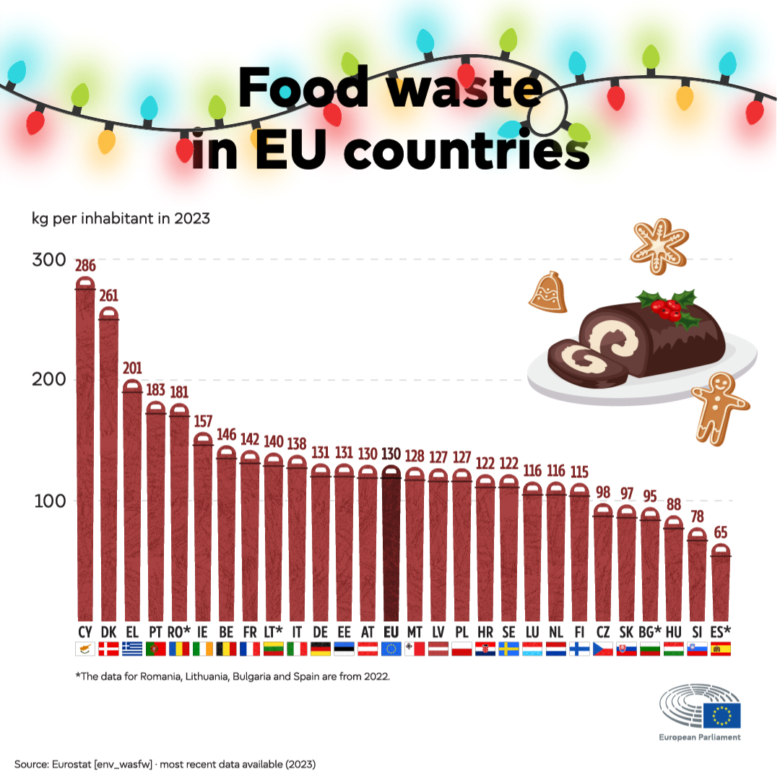

Annex 2. Lesson 5 ‘What Is the Total Made Of? Looking Beneath the Number’
The following image is displayed:

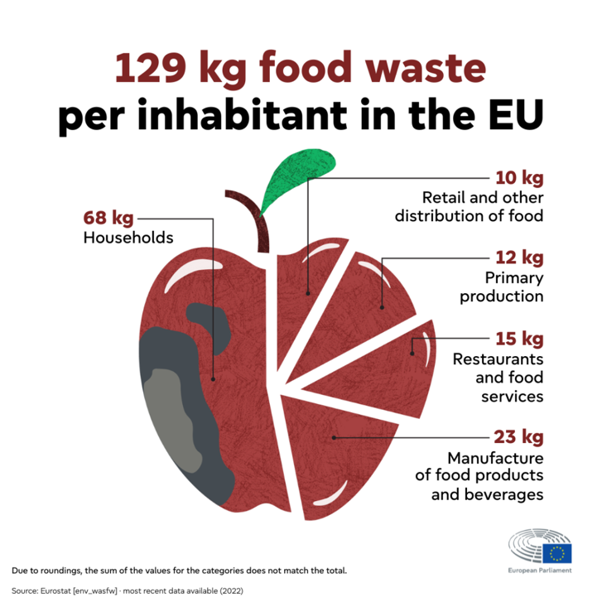

Guided discussion focuses on:
- how this image helps explain where food waste happens,
- how different categories represent different parts of the food system,
- and why looking beneath the total can change how we understand the problem.

Pupils work in pairs to:
- identify one category they are curious about,
- and explain why they think it is important to look at that category separately.

Whole-class synthesis where pupils share:
- one thing the breakdown helps them understand better,
- and one question it raises for further exploration.

Annex 3. Lesson 6 ‘Exploring Food Waste Data Across Europe’
Activity 1: Revisiting total food waste (guided exploration):
- Pupils use CODAP to:
  - create a simple graph of total food waste per capita by country,
  - locate Ireland in the dataset,
  - and calculate or display the mean (average).
- Guided prompts:
  - Is Ireland above or below the mean?
  - Which countries are at the higher and lower ends?
  - Does anything surprise you when you explore the data yourself?

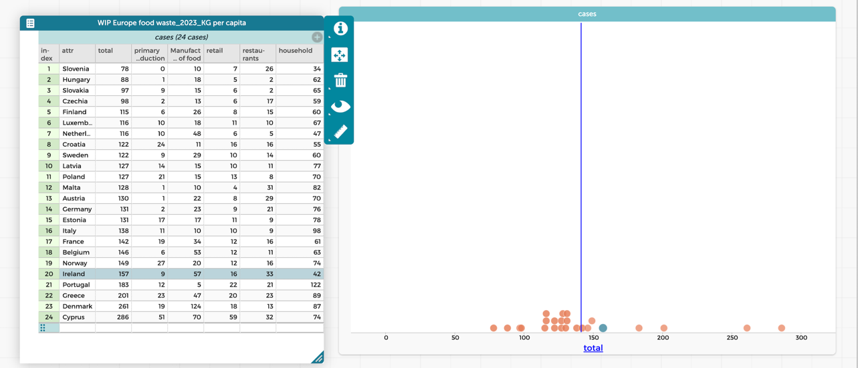

Activity 2: Exploring food waste categories (small-group exploration):
- Pupils work in small groups and choose one or more food waste categories to explore using CODAP.
- Groups are encouraged to follow their curiosity, for example:
  - comparing Ireland to other countries within a category,
  - identifying countries with particularly high or low waste in a category,
  - noticing patterns across categories (e.g. households vs production).
- Teacher provides open exploration prompts, such as:
  - What do you notice?
  - What stands out?
  - What questions does this raise?
- Groups are reminded to use simple evidence-based language:
  - “The data shows…”
  - “We noticed that…”
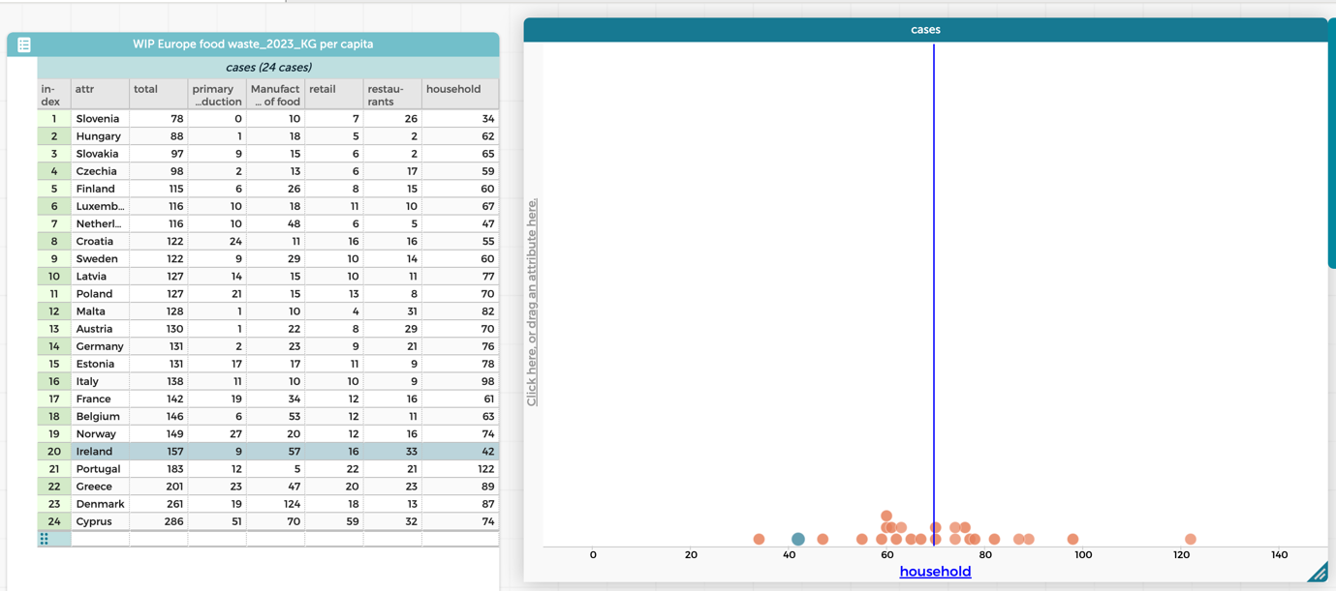

Activity 3: Sharing early findings (whole class):
- Each group shares one interesting observation or question.
- Some groups may report on:
  - Ireland’s strengths or weaknesses in certain categories,
  - differences between countries,
  - or surprising patterns in the data.
- Teacher emphasises that:
  - and different groups may notice different things in the same data.

Annex 4. Lesson 9 ‘How Can We Tell the Story of Our School Food?’

This is Just to Say
BY WILLIAM CARLOS WILLIAMS
I have eaten
the plums
that were in
the icebox

and which
you were probably
saving
for breakfast

Forgive me
they were delicious
so sweet
and so cold

Digging
Seamus Heaney
Between my finger and my thumb
The squat pen rests; snug as a gun.
Under my window, a clean rasping sound
When the spade sinks into gravelly ground:
My father, digging. I look down
Till his straining rump among the flowerbeds
Bends low, comes up twenty years away
Stooping in rhythm through potato drills
Where he was digging.
The coarse boot nestled on the lug, the shaft
Against the inside knee was levered firmly.
He rooted out tall tops, buried the bright edge deep
To scatter new potatoes that we picked,
Loving their cool hardness in our hands.
By God, the old man could handle a spade.
Just like his old man.
My grandfather cut more turf in a day
Than any other man on Toner’s bog.
Once I carried him milk in a bottle
Corked sloppily with paper. He straightened up
To drink it, then fell to right away
Nicking and slicing neatly, heaving sods
Over his shoulder, going down and down
For the good turf. Digging.
The cold smell of potato mould, the squelch and slap
Of soggy peat, the curt cuts of an edge
Through living roots awaken in my head.
But I’ve no spade to follow men like them.
Between my finger and my thumb
The squat pen rests.
I’ll dig with it.
(1966)

Chloe Wise
A Fantastic Ignorance
2016
Oil paint, urethane, dried onion, black pepper, piercing, wood plinth
117 x 46 x 45 cm
https://www.arcadeprojectzine.com/features/nada-ny-2016-highlights
