R4.1. DataScEd4CiEn STEAM Scenario. Economy and Justice. Poverty

Introduction 1
Title 1
Authors 2
Summary of the scenario 2
Age of the students 2
‘Data Science Content in STEAM for Civic Engagement and Social Justice from the Early Years’ 2
Subjects and topics 2
Real-life questions 2
Objectives of the scenario 3
Skills and competencies 3
Teaching approaches and learning strategies/theories 3
Relating the national curriculum with the DataScEd4CiEn scenario 4
Educational Scenario planification 4
Lesson plan 4
Timing 13
Teaching resources (materials & technological tools) 13
Materials 13
Online tools 13
Evaluation 13
Initial assessment 13
Assessment tools 13
Annex 1. Lesson 3. What is extreme poverty? 14
Annex 2. Lesson 4: Dollar street. Let machines learn about the extreme poor and rich! 15
Annex 3. Lesson 5. Comparing needs 19
Activity 1: Poverty since I was born 19
Activity 2: The Global Food Poverty Map 19
Activity 3: Closing the session 20

Introduction

Title
Economy and Justice. Poverty

Authors
Maria Lucia Vargas and Ana Serradó Bayés of Colegio La Salle-Buen Consejo, Puerto Real, Spain.

Summary of the scenario
The scenario aims to confront students with a reflection on the relationship between economy and justice through the comparison between the needs of the students of our school and the needs of students that live in poverty conditions. The scenario has four main parts. Part 1 aims for students to question themselves which are their needs and which are the needs of children living in poverty. Part 2 asks students to become a data scientist and research on the Internet about what extreme poverty is, understanding the stereotypes and social biases about who are extremely poor and how machine learning can help in identifying these biases that may emerge when using machine learning to identify extremely poverty, analysing World Bank data about the percentages of people living with less of 3.65 $ per day with the aim to conclude if the money to eat daily is fairly and equitably distributed on Earth. Part 3 wants that students reflect on the opportunities that fairtrade has and civically engage students in preparing their fair trade market. Finally, the last part, students should critically evaluate why there is that unfairness in the world and what they have learnt from their experience and prepare a fair trade market.

Age of the students
9-10 years old

‘Data Science Content in STEAM for Civic Engagement and Social Justice from the Early Years’

Subjects and topics
The scenario has been constructed as a workshop in which students should bring the knowledge of the different STEAM subjects to understand poverty in the world and look for trade solutions, such as social sciences, arts and mathematics.

Real-life questions
The scenario aims that students reflect on the next questions:
- How do we spend money? The things that we buy, are those equally necessary in our life?
- Do you think that everybody has the same amount of money? Is it fare?
- What do we need in our life? Which are the most important things? In which do we spend more money? Are we able to differentiate between what we want and what we need? Is everybody equal?
- What does extreme poverty mean? Who is in extreme poverty? Where do they live?
- Can a machine learn to identify extreme poverty?
- What is fairtrade? Which are the prices of fairtrade products?
- Can we be civically engaged in preparing a fair trade market?
- Why is the world so unfair? What can we do to change this situation?
- What have you learned from this workshop?

Objectives of the scenario
The objectives of the scenario are:
- Understand the meaning of social justice, the value of what is fair, necessary and good for everybody.
- Be conscious about the need of looking for justice, equity and solidarity in the society to build a more social world and environment
- Recognize the differences between a traditional market and a fair trade market
- Introduce students in a machine learning experience of image identification and analyse possible sources of bias when identifying images of extreme poverty.
- Analyse maps to construct the meaning of distribution and variables.
- Perform a data science investigation on World Bank data about extreme poverty.
- Assign fair prices to common goods

Skills and competencies
Students will develop the skills and competencies related to:
- social justice moral values, the disposition to aid, of support for needs, of concern for poverty and the visibility of certain conditions of inequality,
- problem solving, communication, collaboration, creativeness, critical thinking, openness of mind.

Teaching approaches and learning strategies/theories
The scenario has been designed as a workshop with two phases:
- A inquiry-based STEAM Learning methodological approach, encouraging learners to engage in the scientific process and develop analytical, creative and critical thinking skills. Students are asked to identify the transdisciplinary problem of social justice, the fair, the needs, the goods and the extreme poverty. Formulate research questions and hypotheses about who are and where do they live people with extreme poverty. Design and conduct research (data collection, visualization and analysis) and develop predictive models of images of homes living in extreme poverty using machine learning affordances. Interpret the results in relation to research questions posed, and draw conclusions.
- The conclusions drawn engage students in a project based learning in which they have the problem of creating a fair trade market. Working in small groups, students research the prices of fair and unfair goods and prepare their market and elaborate a decalogue to become economically fair. They critically reflect on what they have learned from the experience.

Relating the national curriculum with the DataScEd4CiEn scenario
In the Andalusian curriculum, a region in Spain, students in Social Sciences are asked to promote and demonstrate a democratic, just, inclusive, respectful and peaceful way of living together based on research and understanding of the social and political nature of human beings and through the critical use of the concepts of law, ethics, civic-mindedness, democracy, justice and peace. At the same time, they should acknowledge what economic inequality and poverty means, analyse its causes and search for local and global solutions.
In mathematics students are expected to:
- use computational thinking, organising data, decomposing into parts, recognising patterns, generalising and interpreting, modifying and creating algorithms in a guided way, to model and automate everyday situations,
- recognise and interpret problems of everyday life and interpret verbal, written and visual messages in situations of economy that help them to make decisions about responsible purchasing,
- analyse and explain processes, the steps followed in solving a problem or the mathematical results, using verbal and graphic language. They are asked to work with statistical data sets and graphs of everyday life: description, interpretation and critical analysis.

Educational Scenario planification
In the next section we describe the lesson plan of the workshop

Lesson plan

Name of the activity | Procedures | Time/Annex
Lesson 1: Is it important to have money?
STEAM subject  Social Sciences | The aim of this first lesson is to help students to understand the social justice issue of extreme poverty.  The lesson has three different moments:  Moment 1. The goods  We suggest beginning the lesson explaining to students that each day we have access to more and more things to buy, for example in the food or textile sector, because production techniques have improved, and we get more and more products. However, this production is creating an imbalance between what some of us have and what others have.  Look at the video about Food imbalance causes until the minute 1.29  Global Food Imbalance & Security - Video | Study.com  Moment 2. The dialogue  We ask students some questions to begin the dialogue about social justice, the value of what is fair, necessary and good for everybody. Here there are some exemplary questions:  - Do you think that global food imbalance also happens in your country?  - What do we buy everyday?  - Do you think that everything is equally necessary?  - Do you need all the toys that you have at home?  - Do you need all the food in your refrigerator or is there some of it that you put in the trash?  - Do you think that everybody has the same? Is that fair?  Moment 3. The Food Waste Index  Look at the video:  The Food Waste Index the essential action needed towards reducing #Foodwaste  And ask students to understand the essential action towards the reduction of the food waste and achieving the SDG 12.3  Reflect with the students on the fair or unfair situation of having food as a need nor as a good.  Ask them about solutions to this problem. Emphasize the possibility of constructing a stall for a fair trade market in the school (which will be the final product of this workshop). Money collected can be donated to a NGO. | 45’
Expected learning outcomes | Understand the meaning of social justice, the value of what is fair, necessary and good for everybody.
Lesson 2: A logo for our fair trade market
STEAM subject  Arts | Having in mind that the final product of this workshop is to create a stall for a fair trade market in the school, the aim of this second lesson is to create a logo for our stall. The lesson has three different moments:  Moment 1: Recognising different fair trade logos  Look at the video to get inspiration about the logo that they can create  Fairtrade logo history, Fair Trade USA, FTF, WFTO  Moment 2: Creating the logo  Ask teams of four students to design a logo for their stall for the fair trade market. It should describe what they understand for fair trade of food.  Moment 3: Reflecting about the logos  The different teams present the logos to the other teams and explain what they have represented.  Ask them: how can the logos help the visitors of the fair trade market to understand the need of a global food imbalance? | 45’
Expected learning outcomes | Be conscious about the need of looking for justice, equity and solidarity in the society to build a more social world and environment
Lesson 3: What is extreme poverty?
STEAM subject  Social sciences or mathematics | The aim of this session is to understand what extreme poverty means. The session has three moments:  Moment 1: If the World Were 100 People  The aim of the activity is to introduce students to the meaning of percentage at the same time that they understand some statistics about people in the world.  If The World Were 100 People | GOOD Data  Ask students to watch the video and construct sentences such as:  - If one hundred people lived on Earth, 11 of 100 would be Europeans. Eleven percent of Europeans lived on Earth. 11% of Europeans lived on Earth.  - If 100 people lived on Earth, 33 of 100 would profess the Christianity. Thirty-three percent of Christians lived on Earth. 33% of Christians lived on Earth.  Moment 2: What is extreme poverty?  Students are asked to visualize the next video and answer some questions, which can be found in the Annex 1. Lesson 3. What is extreme poverty?  Global Citizen Explains: Extreme Poverty  Moment 3: Is extreme poverty equally distributed in Africa?  The aim of this activity is that students begin to use the concepts of distribution and variables using the map Global Poverty Map  This map shows estimates of wealth and poverty around the world. The estimates are computed from satellite imagery, internet data, and other non-traditional sources of data. It uses a machine learning model to predict the wealth of villages where there is no survey data. The Relative Wealth Index predicts the relative standard of living using de-identified connectivity data, satellite imagery and other data sources.  Ask students to navigate the map and discuss the answer of the next questions:  - Is the population equally distributed in Africa?  - Is extreme poverty equally distributed in Africa?  The importance of this activity lies in the visualisation of the colours and length of the prismas. Formalize the notions of distribution and variables. | 45’  Annex 1
Expected learning outcomes | - Understand the meaning of social justice, the value of what is fair, necessary and good for everybody.  - Be conscious about the need of looking for justice, equity and solidarity in the society to build a more social world and environment  - Data map analysis distributions and variables
Lesson 4: Dollar street. Let machines learn about the extreme poor and rich!
STEAM subject  Mathematics | The aim of the lesson is to teach a computer to recognise pictures of houses and classify them in function of the dollar street income of the family. The activity has three moments:  Moment 1: Dollar street  Ask students to access https://www.gapminder.org/dollar-street and let them explore the different images that they can find and express what they are looking for.  Each home has a “dollars per month” assigned. This amount refers to the consumption available to each adult in the family. The income value can vary a lot between countries, they use dollars adjusted for purchasing power parity.  Moment 2: Let machines learn about the extreme poor and rich!  The aim of this activity is to train a machine learning model to recognise pictures of homes and classify them in the four categories of the dollar street:  - From 30 to 125 $  - From 126 to 700 $  - From 701 to 4700 $  - From 4701 to 10090 $  Students need internet  Username and password for machinelearningforkids.co.uk  Dragging and dropping does not work in Internet Explorer. You are suggested to use Firefox or Chrome or explain to them how to copy/paste image URLs from a page.  Only .jpg and .png images can be used.  The students activity can be found in Annex 2  In advance teachers should register teams of students to https://machinelearningforkids.co.uk/  Moment 3: Reflection about machine learning biases of home and poverty  Reflect with the students if the home can be a biased predictor of the extreme poverty of the family. And, if the test of machine learning has given high or small confidence or has given wrong matches when tested. | 90’  Annex 2
Expected learning outcomes | Introduce students in a machine learning experience of image identification and analyse possible sources of bias when identifying images of extreme poverty.
Lesson 5: Comparing needs
STEAM subject  Mathematics | The aim of the lesson is to compare our needs and the needs of the poorest places in the world. We will access the data of the “Word Bank” on the Poverty Count Rate at 3.65 dollars per day established in 2017 and expressed in percentage.  And, we will recall from lesson 3 moment 1, what percentage means, using sentences such as: if there are 100 inhabitants in a country, how many live on less than 3.65 dollars.  https://data.worldbank.org/indicator/SI.POV.LMIC  So that you don't get scared by an entire page in English, the first thing we will do is change the language at the top.  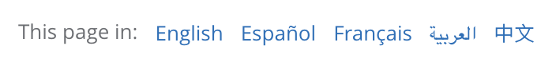  or click directly on the link below  https://datos.bancomundial.org/indicador/SI.POV.LMIC  The students have two activities to carry out.  Activity 1 aims to analyse whether the percentage of people worldwide who eat on less than 3.65 dollars a day has grown or decreased since they were born.  To do this, they need to select a line  And move the lower cursor to the graph between its birth and the latest data:  They must visualize the graph they obtain and from the analysis of it and assess individually, in small group and large group, what has happened in this time interval:  - The percentage of people living on less than $3.65 has grown or decreased.  - in which year there was more poverty  - what happened in 2020 to increase poverty.  Activity 2 aims to analyse the distribution of poverty in the world. To do this, they need to select map:  And, move the cursor to search for which year the maps give them more information. Decide together which year we are going to analyze and answer the following questions:  - What differences do they observe with the colors  - what color Spain has, out of 100 people there are in poverty,  - Why are there countries in Africa in white. Select a country and see what happens in the table at the bottom.  - which country has the most people living on $3.65 a day at most. It is an opportunity to use the term stochastic mode (interpretation as the most frequent data).  Activity 3 aims to close the session with reflection on the results they have obtained from the questions:  - there is the money to eat daily distributed fairly and equitably on Earth,  - How the charts have helped you come to this conclusion.  To develop an adequate analysis, it is necessary that each of the students or at least in pairs has a computer and you accompany them in the search for information.  In addition, answer the questions on the answer sheet that is included in the material, collected and kept for evaluation.  You will find the activity for students in Annex 3. | 45’  Annex 3
Expected learning outcomes | - Perform a data science investigation on World Bank data about extreme poverty.
Lesson 6: Fairtrade is an opportunity!
STEAM subject  Social Sciences or Arts | The aim of the lesson is to recognize the differences between a traditional market and a fair trade market.  Moment 1: Recognising the differences  We suggest that students visit a Non Gubernamental Organization (NGO) which collaborates with a Fair Trade market and explain to them the differences between the traditional trade and the fair trade market.  In case there is any NGO in the locality of the school with a Fair Trade market, students research in what does it means with these two resources:  - The video explaining what Fairtrade is:  https://youtu.be/kkGdx0UYWKk?si=x5MKoEMDaG9eUS2g  - The Webpage of FAIRTRADE INTERNATIONAL  https://www.fairtrade.net/en.html  Moment 2: Reflecting about the opportunities of Fairtrade  We suggest that students grouped in the teams of lesson 2 create a mural or collage explaining what they have learned about Fairtrade. This mural will be part of their stall including the logo created in lesson 1.  Moment 3: Preparing next lesson  We ask every student to bring from home a good. It can be food (one packet of rice, sugar, coffee, chocolate,...) or not (a blanket, a T-shirt,...). | 45’
Expected learning outcomes | Recognize the differences between a traditional market and a fair trade market
Lesson 7: Which is a fair price?
STEAM subject  Mathematics | The aim of the activity is to understand if in the price of a good there is a fair distribution between the work in its production and the cost of it. The activity is divided in two moments:  Moment 1: How much is it?  This moment begins with a reflection on:  “Consumer products that we have at home or that we use frequently have a price that seems “normal” to us, but let’s check what that price includes and how it is distributed”.  Ask teams of students to research about the goods that they have brought from home and their prices:  - price of raw materials  - production costs  - transport costs  - distribution costs  Students are asked to create a pie or bar diagram with this information.  We ask students to reflect on:  - Which part of the whole process takes the most money?  - Does it seem like a fair distribution?  - Is it fair for the work involved at each stage?  Moment 2: Creating “Fair Price” tags  We will ask students to create “Fair Price” tags with the prices of the goods that they have been analysing in moment 1.  It means that in the tag it will appear on one side the original price of the product and on the other side the fair price (it means the price of raw materials and production costs). | 90’
Expected learning outcomes | Recognize the differences between a traditional market and a fair trade market
Lesson 8: Adding value to our fair trade market
STEAM subject  Social Sciences | The aim of this session is to reflect on what we have learned in the different lessons of the workshop.  Moment 1: Adding social justice value to our fair trade market  Some questions to help students to reflect are:  - What have we learned from the previous lessons?  - Is there a trade fair in the world?  - Why is traditional trade not fair? Why does this unfair situation appear?  - What can we do to change this situation?  These reflections should help students to create their stall for the fair trade market and present the value that Fairtrade has and write their decalogue of faire economists.  Moment 2: Decalogue of fair economists  Each team is asked to write 3 or 4 sentences to become fair economists. We will pool the contributions of each team to make up the 10 sentences of the decalogue.  The sentences of each team will be presented on their stall, jointly with their logo and mural. | 45’
Expected learning outcomes | Be conscious about the need of looking for justice, equity and solidarity in the society to build a more social world and environment
Lesson 9: Welcome to our fair trade market
STEAM subject  Social Sciences | Moment 1: Preparing the fair trade market  Each team of students should prepare their fair trade stall including: the goods with the tags of fair prices and unfair prices, the fair trade logo of the team, the mural with the reflections of the opportunities of the fair trade, the sentences written by the team about the decalogue of fair economics, the pie or bar diagram with the information about how prices of the goods are distributed.  Moment 2: Visiting the stall  Members of the school (teachers, staff, families, other students, members of NGO,...) are invited to visit the fair trade market and each stall.  Students of each stall are encouraged to express their civic engagement on the social justice issue of the fairtrade through:  - explaining what the fair trade logo represents,  - presenting the goods that they have selected,  - explaining the pie or bar diagram distribution of prices  - asking visitors which do they think is the estimated fair price of the good,  - explaining which actions of the decalogue are they promoting with this stall | 45’
Expected learning outcomes | Be conscious about the need of looking for justice, equity and solidarity in the society to build a more social world and environment

Timing
Describe for each category the time planned for its implementation
Preparation time: 45’ of lesson 1

Teaching time planned for each of the STEAM subjects
STEAM Social Sciences: 5 lessons of 45’
STEAM Mathematics: 3 lessons of 45’
STEAM Arts: 2 lessons of 45’

Teaching resources (materials & technological tools)
Describe the teaching materials and technological tools to be used in the different lessons

Materials

Online tools

Evaluation

Initial assessment
Lesson 1 will help teachers to understand students' initial beliefs and knowledge about social justice and civic engagement.

Assessment tools
The assessment tools are the different products that students develop during the implementation of the workshop.
Moreover a the exposition of the stall in the lesson number 9 can be considered as a tool for assessing the communicative skills and critical thinking of the students.

Annex 1. Lesson 3. What is extreme poverty?

- Watch as many times as you need the next video till the minute 1:58 and answer the next questions:
https://youtu.be/KoLEnBXsBNg?si=drEx97SHK5G2-bMq

  - Select which human resources are deprived of extreme poverty people:

  Education |   Equity |   Water and sanitation |   Energy
  Food |   Health |   Work |   Peace

- Decide if this sentence is right or wrong:
About 736 million of people apparently live with less of 1.90$ a day

- In which of these regions of the world live the majority of the people in extreme poverty?
- Africa
- Arab states
- Asia and the Pacific
- Europe
- North America
- Latin America
- The Caribbean
- How many people are expected to live in extreme poverty in 2020? Which percentage is?

Annex 2. Lesson 4: Dollar street. Let machines learn about the extreme poor and rich!

In this project you will train and test a machine to sort photos about home and assign the dollar street income of the family.

Objective:
Train and test a machine learning to sort photos about homes and assign the dollar street income of the family.

Phase 1. Access to the machine learning environment
- Go to https://machinelearningforkids.co.uk/ in a Firefox or Chrome browser.
- Login using the username/password provided by your teacher
- Click on “Projects” in the top menu bar.
- Click on the “+Add a new project” button.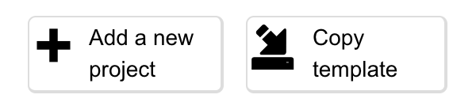
- Create a project called “Homes Wealth”, set to recognise images and make sure you tick the “Whole-class project” checkbox.
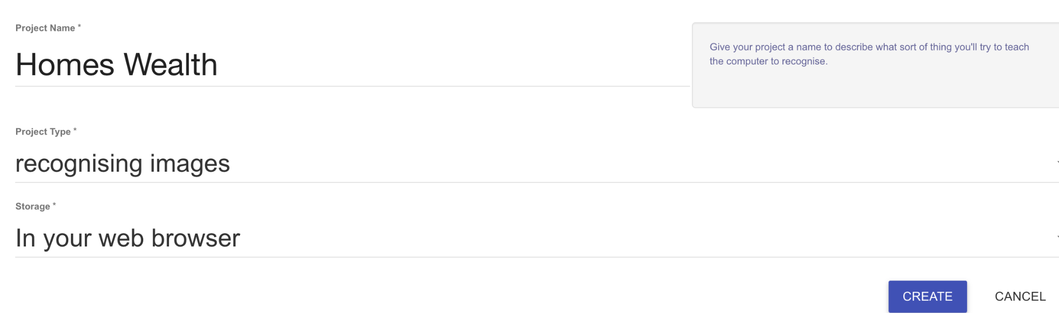
- Click on create.

- Click on the “Homes Wealth” project in the list.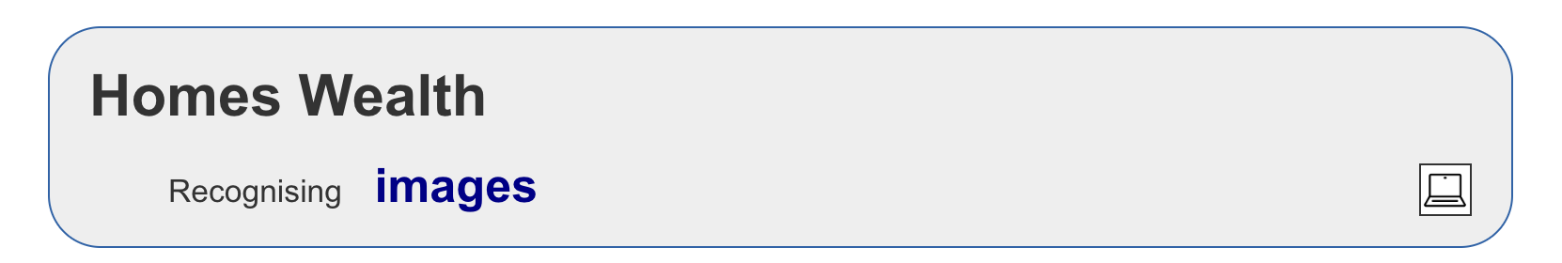
Phase 2. Train the machine learning to sort photos about homes due to the dollar street income of the family
- Click on Train
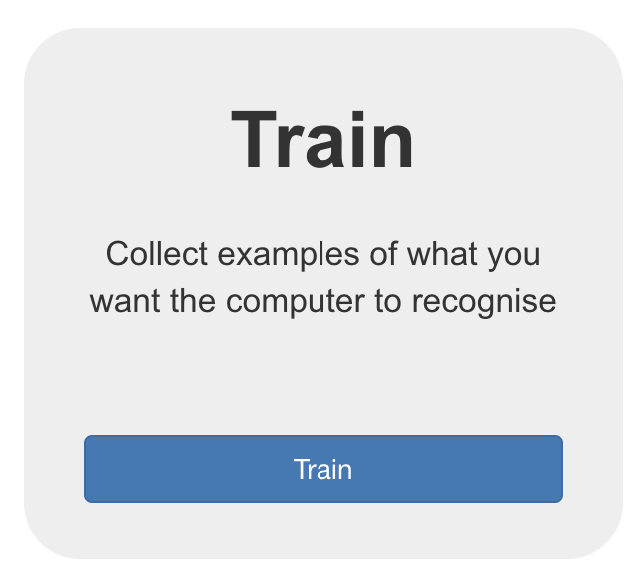
- Click on “Add new label”
- Add four labels, named respectively:
  - From 30 to 125 $
  - From 126 to 700 $
  - From 701 to 4700 $
  - From 4701 to 10090 $
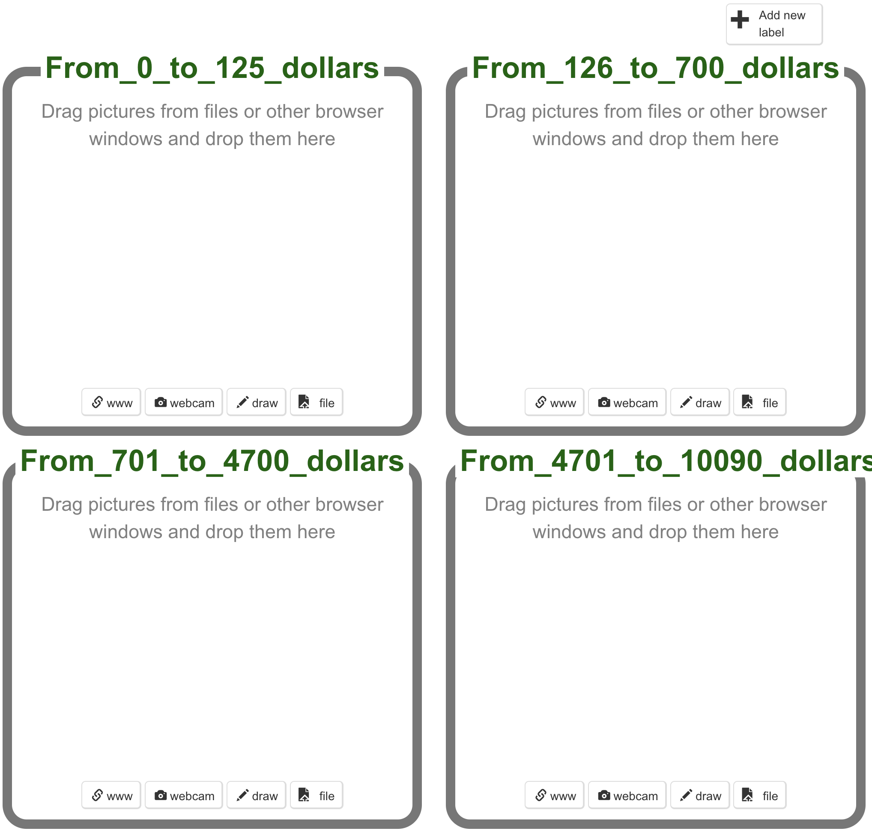
- Access to the next folder where you can find images to train your machine.
Train images
Download the images at your computer folder
- Arrange browser windows so that they are side by side with your computer folder where the train images are saved.
- Drag the images in the corresponding box. The images are named with the “dollar_street month income (number)_ Country.png”.
- Select the file on the corresponding folder and upload the photograph.
- Repeat the process until you have classified all the images of the computer folder in the machine learning boxes.
- Keep going until your class has collected at least 5 examples for each box.

Don’t move past this step until your teacher tells you that it is time to move on

Phase 3. Learn and test the machine
- Click on the Learn & Test
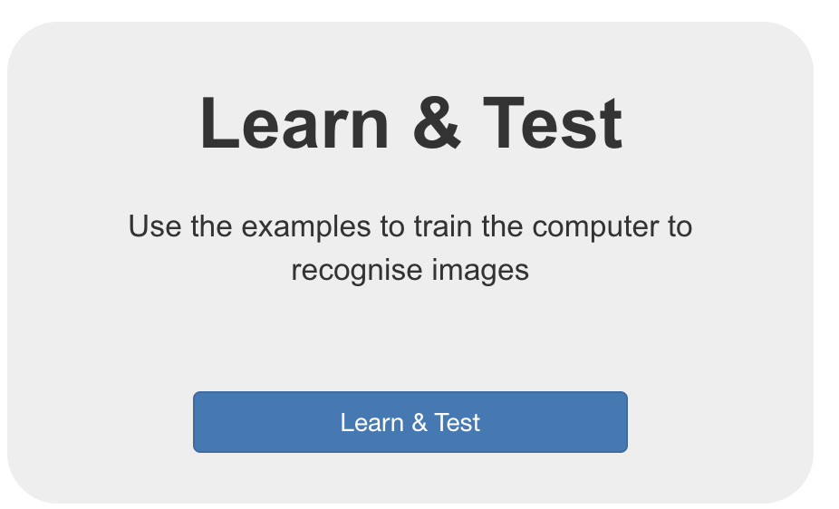
- When you are ready to proceed, click “Train new machine learning model” to train a new model using the examples provided in the test folder (remember to downlow these images in your computer to upload them). The folder with the images is: Learn & test images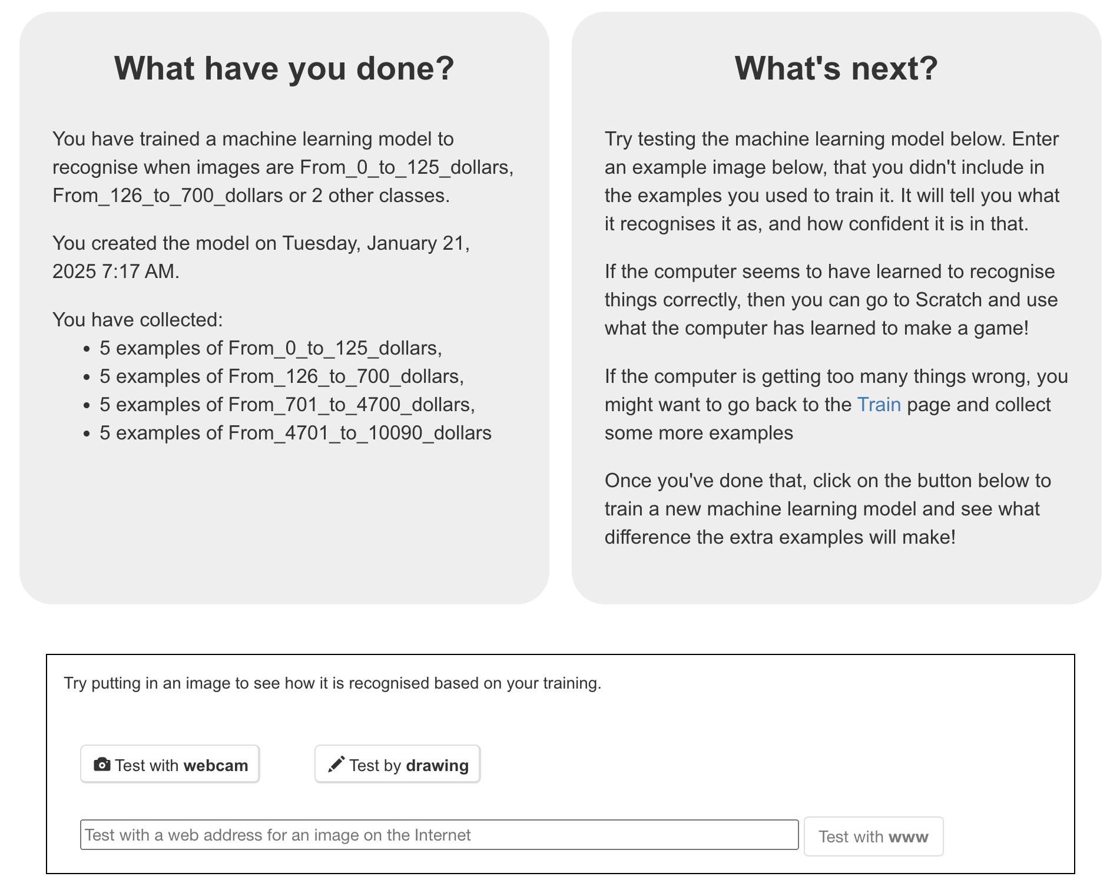
- Select the image 81_Cote d’Ivoire and drag it in the box:
- The machine answers you: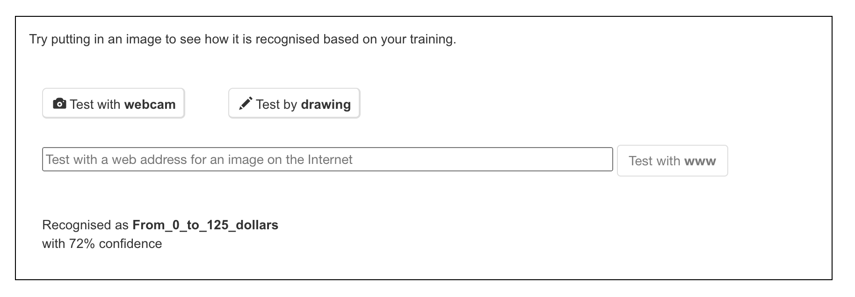
- Recognised as From_0_to_125 dollars with a 72% confidence. The box recognised is the correct answer for this home photography because the dollar street income was 81 dollars a month.
- Click new machine learning model
- And, proceed from point 3 to 5 with another image.
  - If the image is correctly sorted, proceed again from point 3 to 5 with another image.
  - If the image is incorrectly sorted, click on “back to the project” and click on “train”. Sort this incorrect home photography in the correct box, to train your machine.

Phase 4. Learn and train
You have started to train a computer to recognise home photographs. Instead of trying to write rules to be able to do this, you are doing it by collecting examples: training and test photographs. These examples have been used to train the machine learning “model”.

This is called “supervised learning” because of the way you are supervising the computer’s training because you know the dollar street a month income of the family living in that home.

The computer will learn from patterns in the example photos you have in the folders, such as the shapes and the use of colour. They will be used to be able to recognise new images, such as those that you can find on the Internet.

- Access again “Homes wealth” project
- Click on “learn and test”
- Look for an image of a home in the Internet browser.
- Use the right button over the image to “copy the address of the image”
- Paste the link you have copied into the box:
- And click on the “test with www” button, which is right to the box.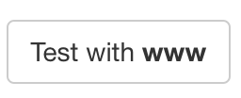
- Has the machine been able to recognise the box of this image?

Annex 3. Lesson 5. Comparing needs
- Click on the link below:
https://datos.bancomundial.org/indicador/SI.POV.LMIC

Activity 1: Poverty since I was born
- In the link above, click online

Move the bottom cursor of the graph between your year of birth and the latest data:
Answer the following questions:
- Has the number of people in 100 living in the world on less than $3.65 increased (grown) or decreased (decreased)?

- In which year was there more poverty?

- In which year was there less poverty?

- What happened in 2020 to increase poverty?

Activity 2: The Global Food Poverty Map
2. Click on the map,
Move the bottom cursor of the graph to the year indicated by your teacher.
Answer the following questions:
- What differences do you observe with colors?

- When you position yourself on two similar colors, what differences do you observe?

- What shade of colour does Spain have compared to other countries? How do you interpret this color?

- Out of 100 people in Spain, how many are in food poverty?

- Why are there countries in Africa in white?

- Which country has the most people living on $3.65 a day at most?

Activity 3: Closing the session
3. Answer the following questions as a team:
- Is the money that the population receives distributed fairly and equitably in our world?

- How have the charts helped you come to this conclusion?

